A REPORT ON

BIONIC LEG

PROJECT ASSESSMENT (Semester 5)
IN

FACULTY OF COMPUTING SKILLS EDUCATION
BY

RIKVENDER SINGH RAJAWAT
UNDER THE GUIDANCE OF

Mr. Dinesh Kumar Choudhary



FACULTY OF COMPUTING SKILLS EDUCATION

BHARTIYA SKILL DEVELOPMENT UNIVERSITY, JAIPUR

November 2023

INDEX
Sr. No. | Content | Page No.
1. | Introduction of Bionic Leg | 3
2. | Benefits of Bionic Leg | 4
3. | Key Features of Bionic Leg | 5
4. | Required Components | 6
5. | Problem Statement | 7
6. | Cost of Project | 8
7. | Initial Circuit Diagram | 9
8. | Code of Project | 10
9. | Explanation of Code | 11-12
10. | Final design | 13

Introduction of Bionic Leg

Bionic legs are like super-smart artificial limbs that help people who lost their real legs. These cool devices are made using fancy technology, sensors, and computer chips. What makes them super cool is that they can copy how real legs move and adjust to different situations.

The best part is that bionic legs are not one-size-fits-all. They're customized to fit each person perfectly, making them comfortable and easy to use.

For people who use bionic legs, it's like getting a superpower. They can run, jump, and do all sorts of activities they couldn't do before. It makes them feel more independent and confident.

But bionic legs aren't just cool for the people who use them. They're also changing how we think about disabilities. They show that everyone should have the chance to live life to the fullest, no matter what challenges they face.

So, bionic legs are more than just a piece of technology; they're like a symbol of possibility and a brighter future for everyone.

Benefits of Bionic Leg

- Better Walking:
Bionic legs help people walk and move more easily, just like real legs.
- Happier Life:
They make people happier by letting them do more things and be more independent.
- Comfy Fit:
Bionic legs are made to fit each person perfectly, so they're super comfortable to wear.
- Less Health Problems:
They can also help reduce health problems that can happen when you can't move much.
- Feel Good:
Using bionic legs can make people feel good about themselves and more confident.
- More Independence:
They allow people to do things on their own, reducing the need for help from others.
- Include Everyone:
Bionic legs help include everyone, no matter their abilities, in our society.
Key Features of Bionic Leg

- Real-Like Movement:
Bionic legs move like real legs, allowing people to walk, run, and do things as if they had natural legs.
- Custom Fit:
They're made to fit perfectly for each person, so they're comfy and easy to wear.
- Adjust to Different Situations:
Bionic legs can change how they work to match what the person is doing, like walking on different surfaces or going up stairs.
- No More Limits:
They help people do more things and feel more confident, reducing the limits that come with missing a leg.
- Reduce Health Problems:
Using bionic legs can help prevent health issues like muscle problems that can happen when people can't move around much.
- Independence:
They let people do things on their own, which makes them more independent and less reliant on others.

Required Components In Bionic Leg Project
- Arduino Uno ( 1 )
- Servo (SG90) ( 2 )
- EMG Kit (AD8232) ( 1 )
- Piezoelectric Sensor ( 4 )
- 12v Rechargeable Battery ( 1 )
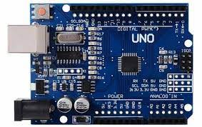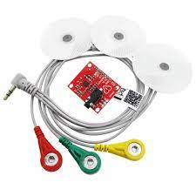
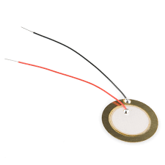


Problem Statement

- Servo Motor Calibration
- EMG Kit Installing
- Final Design
- Initial Position of Servos
- Bionic Leg Connecting with IOT Cloud
- Final Circuit

Cost of Project

Sr. No. | Components | Price | Quantity | Total Cost
1 | Arduino Uno | 285 | 1 | 285
2 | Servo (SG90) | 138 | 2 | 276
3 | EMG Kit (AD8232) | 454 | 1 | 454
4 | Piezo. Sensor | 10 | 4 | 40
5 | 12v Battery | 644 | 1 | 644
Total Cost |  |  |  | Rs. 1699

Initial Circuit Diagram

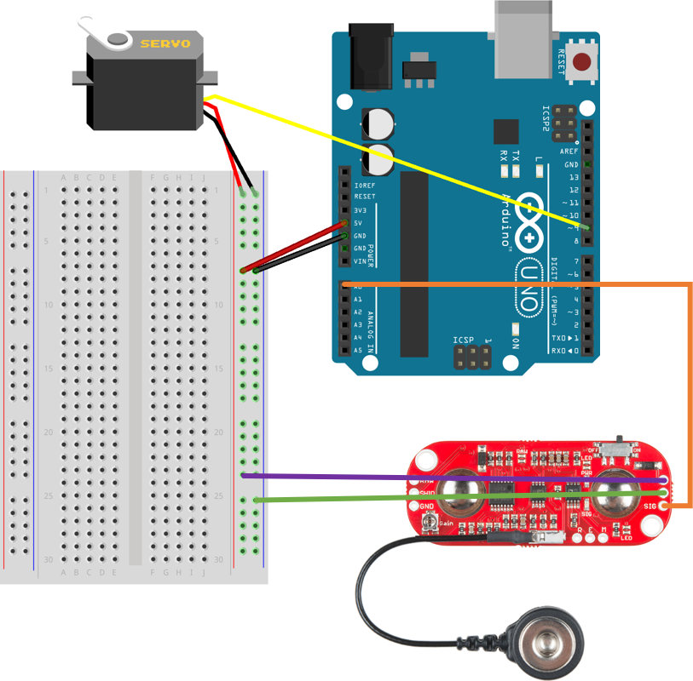

Code of Project

#include <Servo.h>

#define THRESHOLD 340
#define EMG_PIN A0

#define SERVO_PIN_1 3
#define SERVO_PIN_2 5

Servo SERVO_1;
Servo SERVO_2;

#define CLOCKWISE_ANGLE 170
#define ANTICLOCKWISE_ANGLE 10

void setup() {
Serial.begin(115200);
SERVO_1.attach(SERVO_PIN_1);
SERVO_2.attach(SERVO_PIN_2);
}

void loop() {
int value = analogRead(EMG_PIN);

if (value > THRESHOLD) {
SERVO_1.write(CLOCKWISE_ANGLE);
SERVO_2.write(ANTICLOCKWISE_ANGLE);
} else {
SERVO_1.write(ANTICLOCKWISE_ANGLE);
SERVO_2.write(CLOCKWISE_ANGLE);
}

Serial.println(value);

delay(1000);
}

Explanation of Code

Servo Motors:
The project utilizes two Servo motors, denoted as SERVO_1 and SERVO_2. These motors are responsible for simulating leg movement.
EMG Sensor:
An EMG sensor is employed to detect electrical signals generated by muscle activity. It is connected to the analog pin A0 of the Arduino.
Arduino Board:
The Arduino microcontroller processes EMG readings and controls the Servo motors.
Servo Library:
The project leverages the Servo library (Servo.h) for easy servo motor control.
Threshold Setting:
The code uses a predefined threshold value, THRESHOLD, which is set to 340. This threshold is crucial for distinguishing between muscle activation and relaxation.
Servo Motor Control:
The Servo motors are pivotal in this project, providing the leg movement. Two angles, CLOCKWISE_ANGLE and ANTICLOCKWISE_ANGLE, are used for controlling the Servo motors. When muscle activity is detected, the leg moves in the direction defined by these angles.

Setup Function:
The setup() function initializes the project. It is responsible for two main tasks:

Serial Communication:
The code begins serial communication at a baud rate of 115200, enabling debugging and monitoring of EMG sensor values.
Servo Initialization:
It attaches the Servo motors (SERVO_1 and SERVO_2) to their respective pins (SERVO_PIN_1 and SERVO_PIN_2), allowing precise control of the leg movement.
Loop Function:
The loop() function serves as the project's main control loop. In this loop:

The EMG sensor (connected to EMG_PIN) continuously reads muscle signals, represented as 'value.'
If 'value' exceeds the pre-defined threshold (THRESHOLD), SERVO_1 rotates to CLOCKWISE_ANGLE, while SERVO_2 rotates to ANTICLOCKWISE_ANGLE. This combination simulates a specific leg movement.
Conversely, if 'value' is below the threshold, SERVO_1 and SERVO_2 rotate in the opposite direction to simulate another leg movement.
The code additionally displays the 'value' read from the EMG sensor using Serial.println() for monitoring.
Delay Function:
A delay of 1000 milliseconds (1 second) is included in the loop to ensure stability and control responsiveness by introducing a time interval between updates.

Final Design

